Job Safety Analysis
Site: NVA06A |  |  |  | Date: 3/19/26
Activity/Job: UPS-P3-110-01 BATT CAB 01&02 Lion Tamer System Inspection |  |  |  | Equipment/System: UPS-P3-110-01 BATT CAB 01&02
Equipment Make and Model: |  |  |  | Department: Critical Operations
Required Training: Qualified Person training |  |  |  | Required PPE: Class 0 Electrical gloves with lather protector, Arc flash gear, Safety shoes
Prepared By: Noah Lloyd |  |  |  | Task Supervisor:
Directions:  - Identify relevant Energy Wheel sections for task's energy sources.  - Consider potential hazards (e.g., shock, burns).  - Identify existing controls to mitigate risks.  - Determine if more safeguards are needed.  - Implement necessary controls before task.  - Adjust safeguards if new hazards arise.  - Review/update job safety assessment prior to work.  - Add/delete rows as needed.  - Insert photos as appropriate. |  |  |  |  |  | 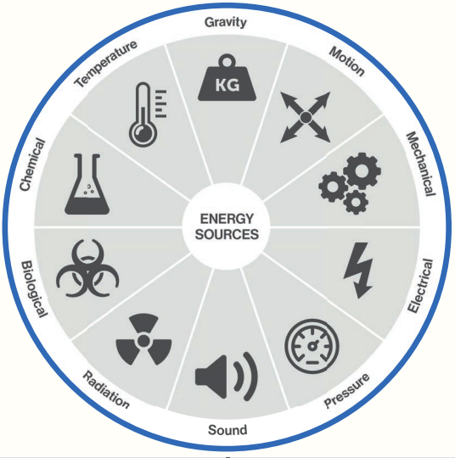
Tasks/Steps | Energy Source |  | Hazard |  | Controls & Safeguards
Opening/CKT | Electrical |  | Arc flash |  | - Wear Arc flash gear.
Opening/CKT | Electrical |  | Electrical shock |  | - Wear electric gloves.  - Handle panel covers carefully.  - Avoid direct contact with breakers, cables and bus bars.  - Use two men rule.
Approved By:
Name |  | Signature |  |  |  |  | Date
I have read and understand the contents of the job safety analysis (JSA) and the controls required to mitigate the risks from the idenitified hazards.
Name |  | Signature |  |  |  |  | Date

